WGSAM skill assessment progress, 28 April 2023

Attending: Vanessa Trijoulet, Sarah Gaichas, Valerio Bartolino, Gustav Delius, Igor Celic, Caroline McKeon, Grant Adams, Gavin Fay, Alfonso, Robert Thorpe, Mike Spence, Pierre-Yeves Hernvann, Laurel Smith, Michael Tomson, Will Butler, Daniel Howell, Ching Villenueva

ms-keyrun repo: <https://github.com/NOAA-EDAB/ms-keyrun>

Issues: <https://github.com/NOAA-EDAB/ms-keyrun/issues>

atlantisom repo: <https://github.com/r4atlantis/atlantisom>

Valerio: Overview: brief introduction, modelers group experiences with simulated data so far, data simulation progress, EM progress and plans.

WGSAM ToR C: Skill assessment, a core topic for the group. Establish and apply methods to assess the skill of multispecies models intended for operational advice. Understand strengths and weaknesses of different models (not a competition), what can these models offer in terms of strategic and tactical advice, can we have a “permanent benchmark” of methods. We want a framework to test methodology before it is used.

Process: Atlantis model (NOBA) → atlantisom→ mskeyrun dataset → estimation models, a wide array. Some of these models can be run as single species, offer an opportunity to expand towards what a multispecies framework can offer relative to single species models.

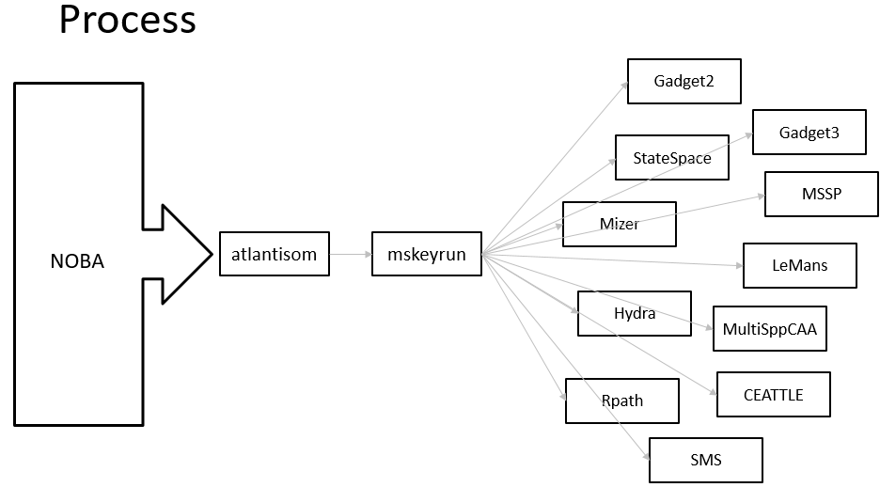

Gustav: capture what can be observed in a real world scenario, things we wouldn’t know? Yes in general.

Sarah: we are giving each modeler a common set of starting values or certain parameters so that we can understand differences between models.

Grant (chat): Is there a list of the aspects that modelers should aim to keep the same? Thinking selectivity, q, etc setups.

Valerio: we can add other scenarios looking at different aspects of data problems.

Just at the beginning dealing with the data. Understand where we are with different models. Progress from the modelers? Then jump on different data issues. Spend most time on this.

Model progress:

**Team Gadget** (Valerio et al): using an intermediate tool called mfdb to make a database to automate bringing into Gadget models. Tool to build the model for multiple simulation inputs, and reducing error. So far mfdb → cod, haddock (capelin to come) in Gadget2. Starting from single species models. Based on diet information in mskeyrun using these three species. In <https://github.com/gadget-framework/wgsam-skill-assessment> have been able to work on haddock and cod, all files on github. Length dist from commercial fleet and surveys Q1,3, age length key from Q1 survey and indices of abundance form both the surveys. Timestep quarterly. Length distribution aggregated over a year for fitting. Can we do quarterly length dist? (yes, on the list, should be able to). Age length distribution from mskeyrun. Age information is by age class which groups more than one annual age for cod and haddock (age1-2, 3-4, …). This is reflected internally in the model while fitting the age-length key. Haven’t used diet data yet. Fits to survey indices for cod, age length comps for cod, quarterly fits. It could be useful to keep aside 20-30 years of data to evaluate forecasts? vonB fits estimated internally, at the moment fixing t0 and Linf and estimating K, use age length key.

Gustav (chat): I suspect that you don't need to keep back any data for testing because I assume that Atlantis can simply be asked to simulate for a few more years into the future. Is that right?

Also, Atlantis can simulate the effect of changes in fishing policy and that would be a useful test on our models

Valerio: discuss issues about age labeling in Atlantis with full group

Valerio: goal is to code as much as possible the process of bringing the data into the model. Yes!

**Team LeMans**: Robert and Mike, haven’t started yet, but could share info with team Hydra and the hydradata R package <https://github.com/thefaylab/hydradata> will be an interesting comparison of the two similar models using this same input dataset.

**Team Mizer** (Gustav et al): purely length based, similar data requirements. It includes density-dependent growth, it would be nice to compare whether there is any payoff for that extra effort. How can we calibrate them so that they are the same except for one extra bit. Havent started yet, Gustav, Caroline and Mike. Looking forward to working on this. Cool to have a good dataset for calibrating.

**Team state-space** (Vanessa): script to extract data in format needed, data→ csv → inputs. Where to put? There are some parameters that won’t be time varying, using time series averages. Main problem related to diet, don’t know how to model size preferences. Using gamma distribution to define size preference, give shape and scale parameters as observations, using weight ratio. Also started with the same three species, cod, haddock, capelin. Biomass of other food should probably be a common assumption. How to treat? Check intermittent feeding interactions. Haven't run yet and not yet on github but can post. Check consumption per capita values, may be in Atlantis. How well will the catch be fitted with such low variance? Would need for each predator

Gustav: use the same size preference as used in Atlantis, which for NOBA is a constant between the min and max gape width (only predator specific, same for all preys). Consumption rates, can we agree not to use them in calibrating the models? Yes, general view that consumption rates should be given as input

Consider a separate meeting on consumption assumptions and Atlantis outputs.

Alfonso: consumption estimate in Atlantis is by length or age? Ageclass (not ideal for some models)

Daniel: total consumption is the most difficult thing to pin down in these models. The more we can standardize and give the models the truth the better, may get wildly different answers just because of this one thing.

**Team CEATTLE** (Grant): script to move mskeyrun data into CEATTLE, pretty close to having an input dataset to run in single species mode, haven’t yet jumped into diet or consumption data yet. Single species stuff coming along well. Have an R script that runs everything to move into CEATTLE format. How to set up? What does selectivity look like, are catchability and selectivity the same between surveys, do we have data to make age length keys for fishery length data, and. Doing all species aside from unfished? Do we want so start with just 3? Could start with the same 3 spp (cod, had, capelin), if some models can do more would be fine too.

Selectivity several suggested to start with a common simple assumption of a sigmoid functional form

Where to host, common github or everyones own github?

Create a folder for the project with subdirectories for each model in the WGSAM github to host consolidated codes and outcomes from the different models<https://github.com/ices-eg/wg_WGSAM>

Vanessa: Agree what are the interactions among the species, do we have haddock eating capelin, and haddock eating itself, really low, should we keep this? Or simplify? Maybe all use the same interaction matrix. Do by email.

Valerio: age issue. Multispecies model probably need to account for ages on a calendar year for all species, which means shifting some of the atlantis ages into calendar ages. We can resolve how we label ages–add weight at age to issue

For instance, can’t follow the cohort between the two surveys if you don’t relabel the ages, but can be done by convention with Valerio’s process.

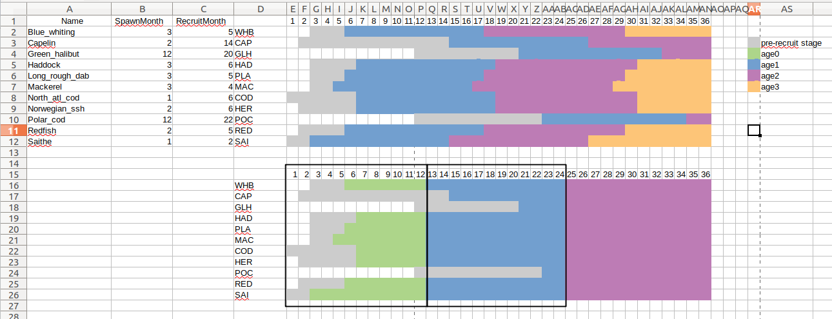

Chat

16:03:00 From Sarah Gaichas she/her To Everyone:

Notes here, do you have access? https://docs.google.com/document/d/1w5dMU3QBc-49LdRMfp-1Jt6tfO4acSbwG_Psn9cNovA/edit?usp=sharing

16:03:16 From Grant Adams To Everyone:

yup

16:17:32 From Grant Adams To Everyone:

Is there a list of the aspects that modelers should aim to keep the same? Thinking selectivity, q, etc setups.

16:30:54 From Sarah Gaichas she/her To Everyone:

better than Hydra was doing :-)

16:32:57 From Gustav Delius To Everyone:

I suspect that you don't need to keep back any data for testing because I assume that Atlantis can simply be asked to simulate for a few more years into the future. Is that right?

16:33:19 From Gustav Delius To Everyone:

Also, Atlantis can simulate the effect of changes in fishing policy and that would be a useful test on our models

16:42:27 From Grant Adams To Everyone:

lololol

16:42:42 From Grant Adams To Everyone:

thankfully no one is using stock synthesis

16:43:13 From Gavin Fay, he/him, UMassD To Everyone:

Atlantis already writes SS files so that would be easier?!

16:43:22 From Grant Adams To Everyone:

I didnt know that!!

16:43:37 From Grant Adams To Everyone:

was thinking of copying and pasting into a .dat file

16:45:45 From Sarah Gaichas she/her To Everyone:

hydradata writes from Rdata to a .dat file; not graceful but at least not by hand

16:47:31 From Grant Adams To Everyone:

was thinking of the same for CEATTLE

17:14:43 From Pierre-Yves Hernvann To Everyone:

I can check how the Atlantis consumption rates are calculated, Sarah

17:22:04 From Grant Adams To Everyone:

100%

17:27:48 From Maria Ching Villanueva To Everyone:

It will be nice to have a summary of what we have discussed today for traceability purposes and such that we can know where we are next time we meet?

17:32:08 From Grant Adams To Everyone:

I have to jump off, it was great seeing everyone! And excited to get some models up and running!!

17:37:24 From Maria Ching Villanueva To Everyone:

Valérie and Sarah, will it be possible to provide the issue list, I imagine, it will be included in the minutes of today’s meeting and circulate the document among us for possible additional comments and questions as we are running out of time?

17:38:29 From Sarah Gaichas she/her To Everyone:

notes are here Ching with all links https://docs.google.com/document/d/1w5dMU3QBc-49LdRMfp-1Jt6tfO4acSbwG_Psn9cNovA/edit?userstoinvite=icelic@ogs.it&actionButton=1

17:40:06 From Maria Ching Villanueva To Everyone:

Can we also send the links and directory for the WGSAM GitHub

17:40:20 From Maria Ching Villanueva To Everyone:

Yes I agree. I can help, if needed

17:40:33 From Maria Ching Villanueva To Everyone:

Yes, that is very good

17:40:48 From Maria Ching Villanueva To Everyone:

Thanks so much Sarah